EXPERIMENT 5
ROLL NO:240701801 NAME:DHARSHAN D

Task Analysis
Task Analysis is the process of breaking down a user's interaction with a system into smaller steps to understand how the user completes a goal. It helps in improving usability and identifying possible issues in the application.

In this experiment, Task Analysis is applied to a Food Delivery Application to understand how users order food from browsing to delivery tracking.

User Flow
User Flow is a visual representation of the steps a user follows to complete a task inside an application. It shows navigation paths, decision points, and different possible outcomes.

User Flow for Food Delivery Application
Start → Open App → Login / Register → Browse Restaurants → Search / Filter → Select Restaurant → View Menu → Select Items → Customize Items → Add to Cart → Open Cart
→ Review Cart → Proceed to Checkout → Enter Delivery Address → Choose Delivery Time
→ Apply Promo Code → Select Payment Method → Make Payment → Payment Confirmation → Place Order → Order Confirmation → Track Order → End

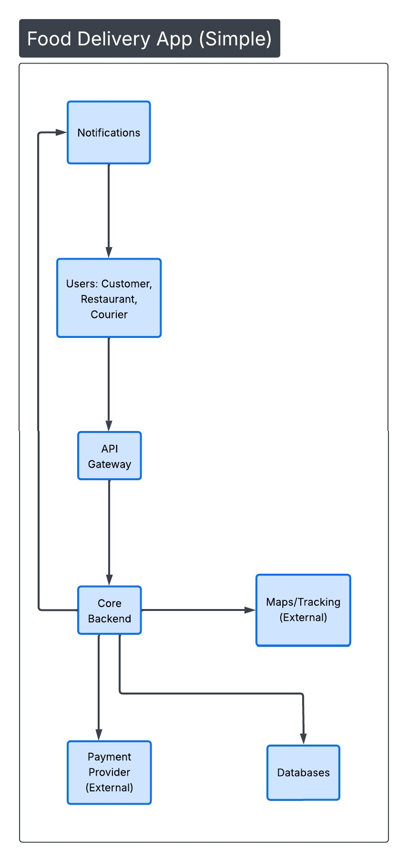
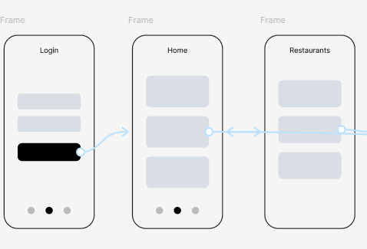

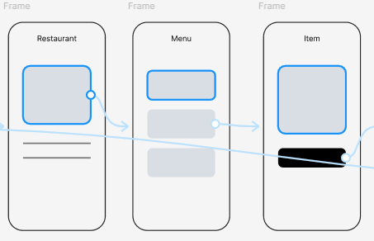

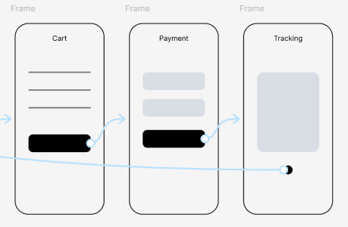

Step 1: Start

- The user opens the Food Delivery application.

Step 2: Login / Sign Up

- If the user is already registered, they log in.
- If not, they create a new account using the Register option.

Step 3: Browse Restaurants

- The system displays nearby restaurants.
- The user can browse or search for specific food items.

Step 4: Select Restaurant

- The user selects a restaurant to view its menu.

Step 5: View Menu and Select Items

- The menu is displayed.
- The user selects food items and customizes them if needed.

Step 6: Add to Cart

- Selected items are added to the cart.
- The user can review items before proceeding.

Step 7: Proceed to Checkout

- The user clicks on Proceed to Checkout.
- If not ready, they can go back to modify the cart.

Step 8: Enter Delivery Details

- The user enters the delivery address.
- The user selects delivery time (ASAP or Schedule).
- Promo codes can be applied if available.

Step 9: Payment Method

- The user chooses between Online Payment or Cash on Delivery (COD).
- If Online Payment is selected, payment is processed and confirmed.

Step 10: Place Order

- After successful payment or COD selection, the order is placed.
- Order confirmation message is displayed.

Step 11: Track Order

- The user can track the order status (Preparing → Out for Delivery → Delivered).

Step 12: End

- The ordering process is completed.
- The user can close the app or place another order.

.

